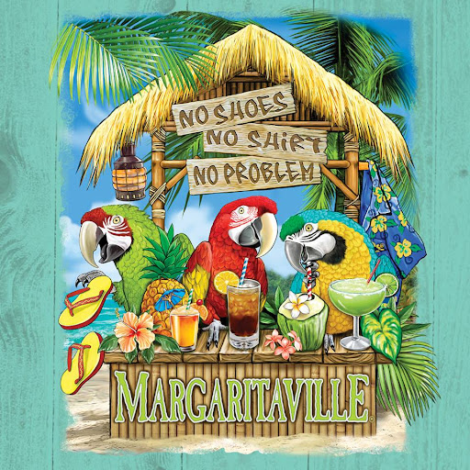  Let’s Party (calling all members)  Please plan to join Newcomers and Old Friends for a fun-filled End-of-Year party with heavy hors d’oeuvres, good tunes with The Boomerangs, leis, dancing, and fun with friends! (Limited to 110 persons, so get your payment in today)  When: Friday June 6, 2025 6:30-9:00 pm  Where: Cunningham Creek Winery  3304 Ruritan Lake Road, Palmyra, VA 22963
  Only $10
  per person
  GOOD FRIENDS!
  Please mail payment to Jean Shore, Treasurer (please indicate “EOY Party” on your check)
  7 Jefferson Drive
  Palmyra, VA 22963
  Or pay at the May 4 meeting
  Catered by:
  WAHOO BBQ
  Menu includes:
  Cheeseburger sliders, pulled pork sliders, chicken and pineapple skewers, bbq eggrolls, coleslaw, chicken wings, hush puppies, veggies and dip, tropical fruit, cheeseball/crackers, margarita cupcakes, cookies, tea/ lemonade
  GOOD FOOD!
  Wine, beer, cider and specialty Margarita drinks for purchase
  GOOD MUSIC!
  Dig out those Hawaiian shirts, flip flops and sunglasses and we will see you there!
  Leis for everyone
  Dig out your Hawaiian shirts and flip flops
  And let’s plan to have a good time!
  Photo Booth
  Lei’s for everyone

